Commissioners’ Journal

2015, FOURTEENTH MEETING

CRAWFORD COUNTY COURTHOUSE, COMMISSIONERS’ BOARD ROOM
Girard, KS Tuesday, February 24, 2015, 10:00 AM

The Crawford County Board of Commissioners met pursuant to Kansas Statutes

Annotated Chapter 19, Article 2, Section 18 in due and regular session with open doors.

Commissioner Carl Wood served as the presiding officer.

Commissioners Tom Moody and Jeff Murphy were in attendance.

County Clerk Don Pyle and County Counselor Jim Emerson were seated with the Board.

Chairman Wood led the pledge of allegiance.

UNDER THE HEADING BUSINESS FROM A PREVIOUS MEETING
CONSENT AGENDA
On motion (15-051) of Commissioner Moody and the second of Commissioner Murphy that the consent agenda be approved including:
- Approval of the February 20, 2015 minutes of the Board of Commissioners.
Yeas: Commissioners Moody, Murphy and Wood
Nays:
Present but not voting:
Absent or not voting:
The motion prevailed and the consent agenda was approved.

SIGNING OF MOTIONS

The County Clerk presented the following motions for Commissioners’ signatures:

Motion 15 | 47 | That the consent agenda be approved including: Approval of the February 13, 2015 minutes
Motion 15 | 48 | To approve the appointment of Daniel Hiben as Deputy Coroner for Labette County as recommended by Coroner Dr. Adam Paoni
Motion 15 | 49 | To appoint Commissioner Jeff Murphy to be the representative for Crawford County on the Southeast Kansas Regional Solid Waste Authority
Motion 15 | 50 | To recess this open session and go into a closed executive session for a period of not more than 30 minutes to discuss personnel matters involving Non-Elected Personnel and to include the Board of County Commissioners and County Counselor Jim Emerson

UNDER THE HEADING NEW BUSINESS
PUBLIC HEARINGS AND OPENING OF ANNOUNCED BIDS
MESSAGES FROM THE PUBLIC

Item One: Representatives from Class LTD, Mosaic and New Hope will discuss their client services. Mr. Scott Thompson, President of Class LTD, discussed the history of Class LTD and that when they started receiving county funds, they were the only provider of services to the developmentally disabled in Crawford County. Commissioner Wood was answered that it is hard to determine if clients have been raised in Crawford County or if they have moved into the county recently and that a small percentage, in the 10% range, may have come from other counties. Mr. Thompson stated that he understands that the distribution of these public funds need to be fair but that a reduction in any of their funding sources will likely lead to reductions in services to clients.

Ms. Leslie Lackamp, Executive Director of Mosaic, stated that it will be a difficult task to divide this funding up in a fair manner and that the number of clients that have moved into the county might be much higher than 10%. John Lair, Executive Director of New Hope, stated that each of the service providers have different types of service that are their specialty and that he feels that being fair with all the service providers is most important.

There was a good discussion of the different types of services provided which are Case Management, Residential and Day services. It was discussed that some clients may use more than one of the service providers and can choose the services that they wish to receive from each provider. It was discussed that the Community Developmental Disability Organization for Crawford, Cherokee, Labette and Montgomery Counties is Class LTD and that they would be the organization that could produce accurate numbers of the individuals receiving services. Mr. Cliff Sperry of the CDDO told the Commissioners that he would work on getting accurate numbers of the clients for them.
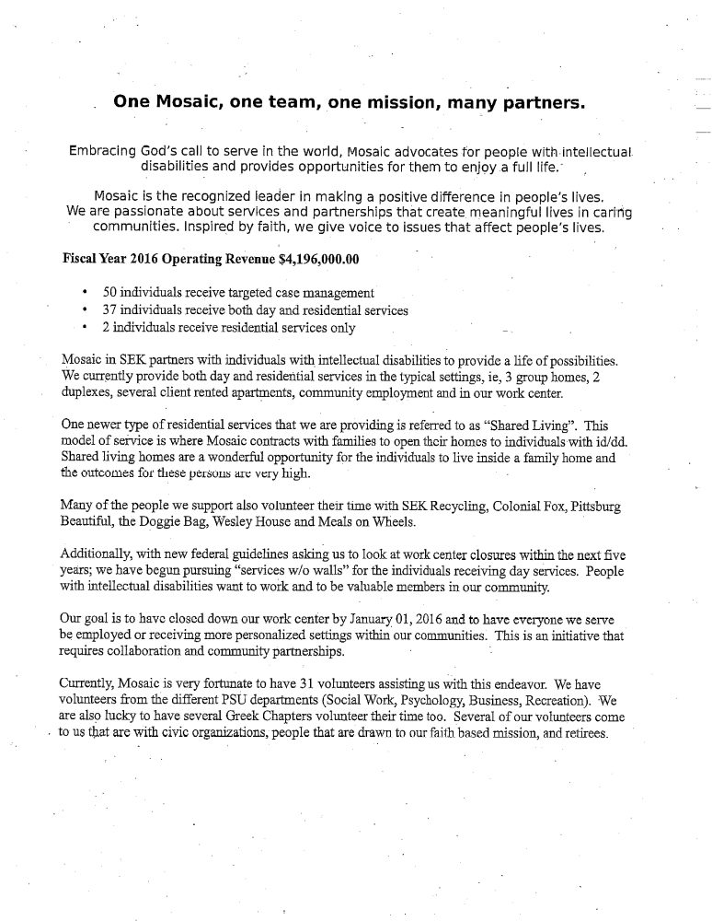
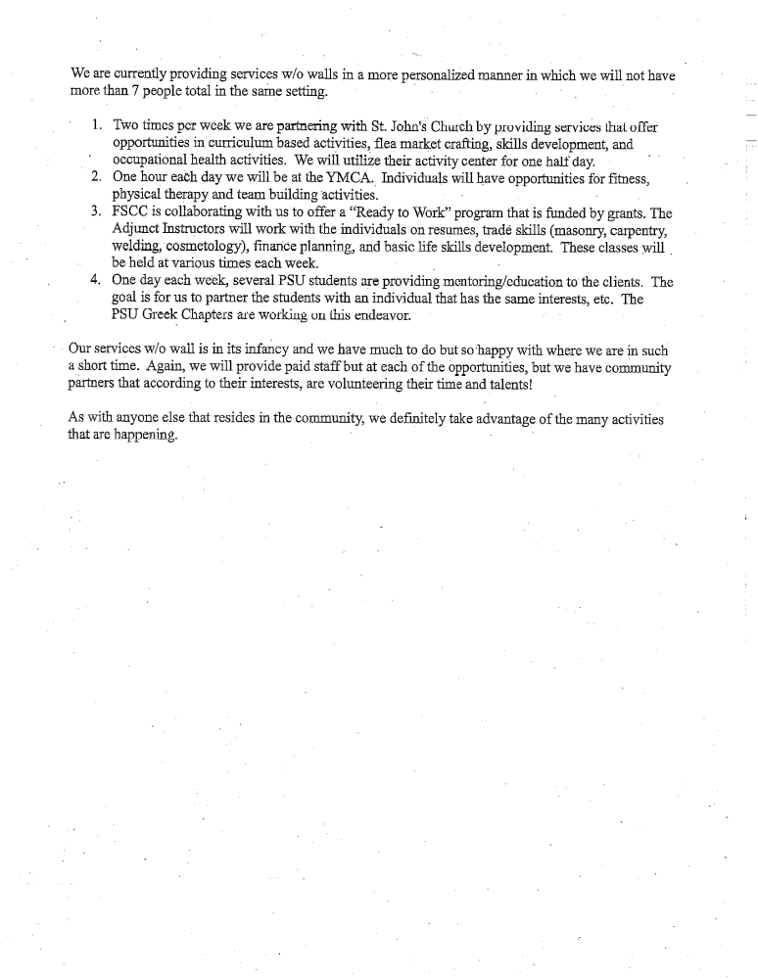

MESSAGES FROM ELECTED OFFICIALS
MESSAGES FROM APPOINTED OFFICIALS
MESSAGES FROM OTHER GOVERNMENTAL ENTITIES
PROCLAMATIONS AND ORDERS OF THE BOARD
NEW BUSINESS:

Item One: County Clerk Don Pyle wanted to be sure that all of the Commissioners had received a copy of the agenda for the February 27, 2015, meeting of the Lottery Gaming Facility Review Board. It was discussed that the actual presentations from the SEK Casino Applicants would not be heard at this time but there would be some planning and discussion of the SEK Gaming Zone Application process. County Counselor Jim Emerson was asked to contact the county lobbyist about attending this meeting.
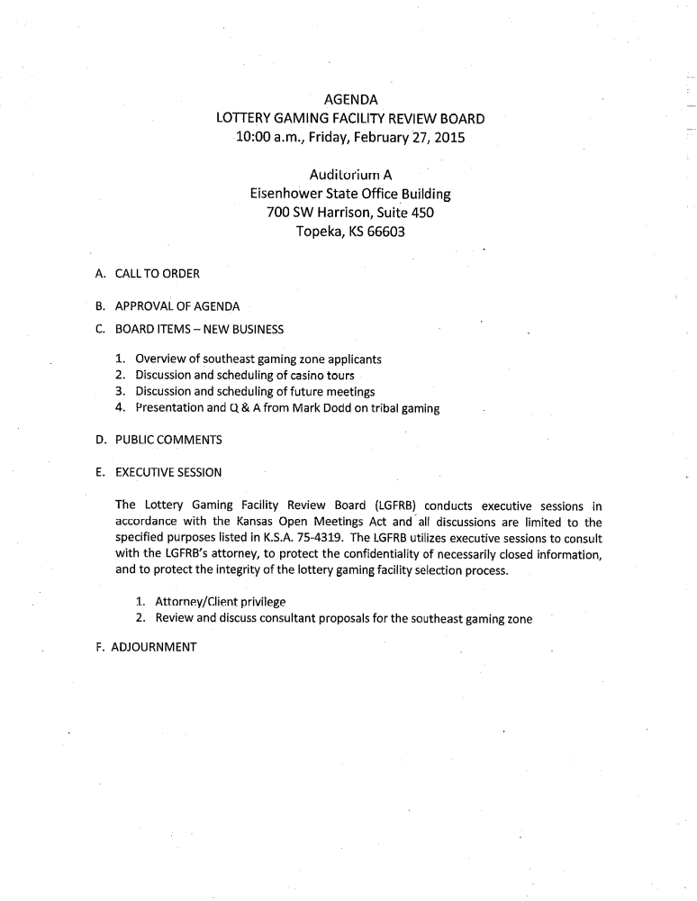
Item Two: County Counselor Jim Emerson regarding the Notice of Hearing for a proposed road vacation. Mr. Emerson stated that the road that the vacation is being requested for is located in the 1200 West Block of 660th Avenue just south of Walnut.
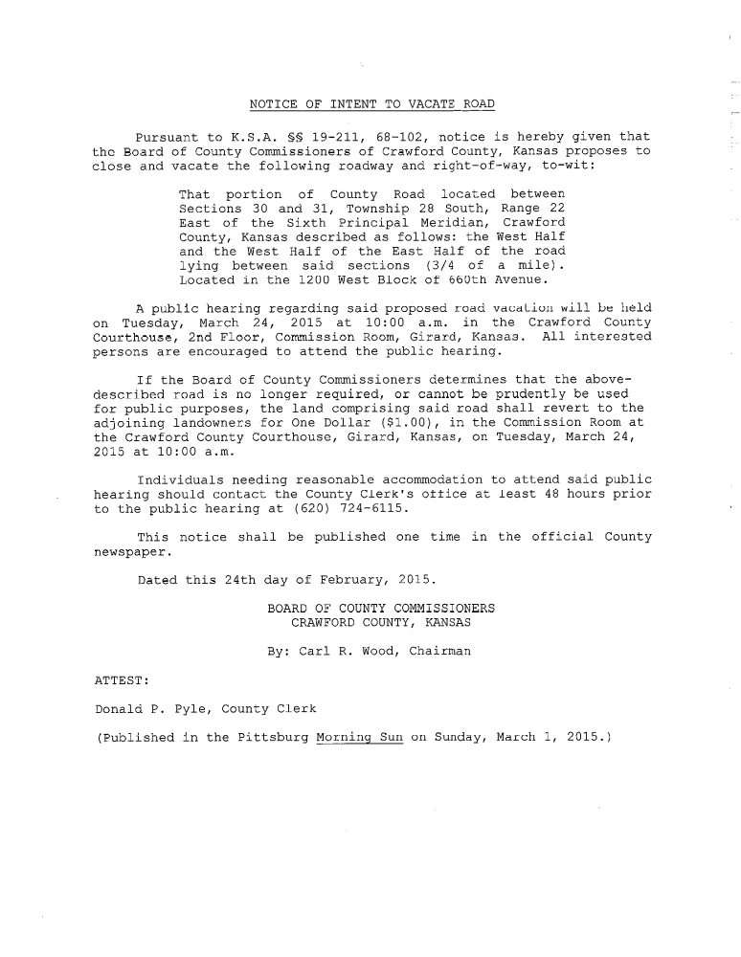

On motion (15-052) of Commissioner Murphy and the second of Commissioner Moody to approve the Publication of the Notice of Intent To Vacate a Portion of the Road Located in the 1200 West Block of 660th Avenue.
Yeas: Commissioners Moody, Murphy and Wood
Nays:
Present but not voting:
Absent or not voting:
The motion prevailed.

Item Three: County Counselor Jim Emerson regarding the Notice of Hearing for a proposed road vacation. Mr. Emerson stated that all of the platted streets and alleys that were requested to be vacated are unopened and are located in Jewell Center which is very close to Arcadia.
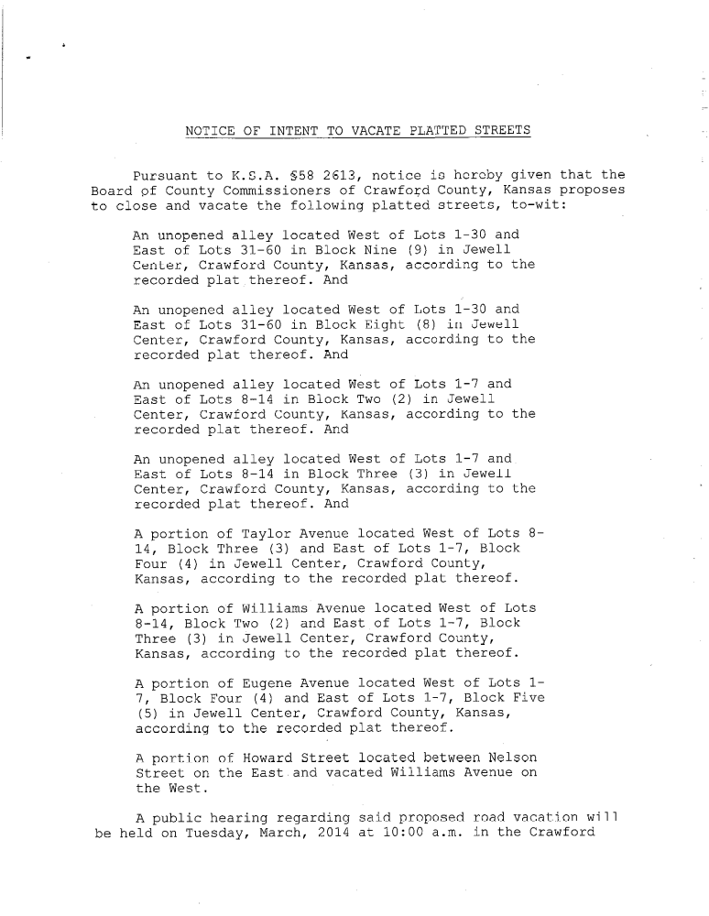
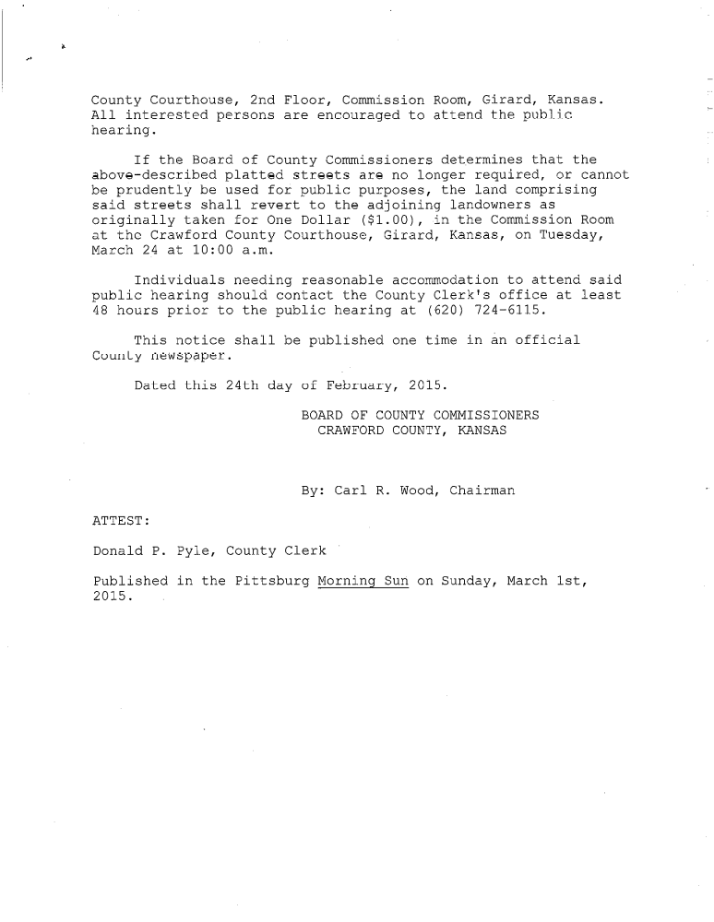
On motion (15-053) of Commissioner Moody and the second of Commissioner Murphy to approve the Publication of the Notice of Intent To Vacate Platted Streets and Alleys in Jewell Center.
Yeas: Commissioners Moody, Murphy and Wood
Nays:
Present but not voting:
Absent or not voting:
The motion prevailed.

Item Four: Commissioner Murphy regarding a conversation with Julie Smith of the Girard Chamber of Commerce in regards to the grant that the City of Girard has received for Downtown Streetscape Project. There was a discussion of the project and that much of the sidewalks on the courthouse side of the streets were not included in the project. It was discussed that the replacement of these sidewalks could be very expensive.

Item Five: Commissioner Wood regarding a workshop for vendors of the plastic drain pipes to demonstrate the proper techniques for backfilling and packing the areas around these culverts. Commissioner Murphy stated that he would also like to learn more about the use of the V-shaped ends for culverts. The Commissioners were going to have a date for a demonstration scheduled for the near future.

UNDER THE HEADING OLD BUSINESS
Item One: Commissioner Wood mentioned that the First Aid classes for county employees that will be held on the third Friday of each month began on February 20, 2015. Commissioner Wood stated that there was a good attendance and that he would like to have all county employees attend a class.
EXECUTIVE SESSION
Item One: Commissioner Wood requesting an Executive Session to discuss personnel issues that involve non-elected personnel.

On motion (15-054) of Commissioner Wood and the second of Commissioner Moody to recess this open session and go into a closed executive session for a period of not more than 30 minutes to discuss personnel matters involving Non-Elected Personnel and to include the Board of County Commissioners, County Clerk Don Pyle, Fiscal Office Director Larissa Bowman and County Counselor Jim Emerson.
Yeas: Commissioners Moody, Murphy and Wood
Nays:
Present but not voting:
Absent or not voting:
The motion prevailed.

The Commissioners went into Executive Session at 11:24 AM and reconvened the Open Session at 11:54 AM with no action taken except to go back into open session.

Under the heading future business and announcements
FUTURE BUSINESS:
Item One: Friday, February 27, 2015, 9:00 AM – Work Session with Greg Hite and the Road & Bridge Foremen regarding pickup trucks.

Item Two: Friday, February 27 – Ms. Wilda Pentola from Girard Area Community Foundation and Ms. Cathy White from Community Foundation of SEK addressing “Keep 5 in Kansas”.

Item Three: Friday, February 27, 2015, At the End of the Regular Session – Work Session with Liz Hart, Road & Bridge Office Manager on Bridge Work for 2015.

Item Four: Tuesday, March 3, 2015, 9:00 AM – Work Session with Joey Adams, Crawford County EMS Director.

ANNOUNCEMENTS:
UNDER THE HEADING MOTION TO ADJOURN
MOTION TO ADJOURN
Item One: Adjournment

On the motion of Commissioner Wood and the second of Commissioner Murphy to adjourn the February 24, 2015 meeting of the Board of Crawford County Commissioners at 12:04 AM and to reconvene at the next regularly scheduled time with open doors.
Yeas: Commissioners Moody, Murphy and Wood
Nays:
Present but not voting:
Absent or not voting:
The motion prevailed.

In Testimony whereof, I have hereunto set my hand and caused to be affixed my official seal and submitted these minutes for the approval of the Board of Crawford County Commissioners:

__________________________
Don Pyle
County Clerk

<>

This submission completed at the Crawford County Courthouse in Girard.
Taken by DPP 2/24/15 at 12:04 PM, Amended by DPP 2/26/15 at 1:08 PM

